# Asana

Pro’s:

* Easy to learn/use
* Easy to see who is taking on what task
* Calendar view of tasks
* Potential for tracking hours as well with add-ons
* Slack Integration
* Some primitive tracking of progress (probably as much as we will need)
* 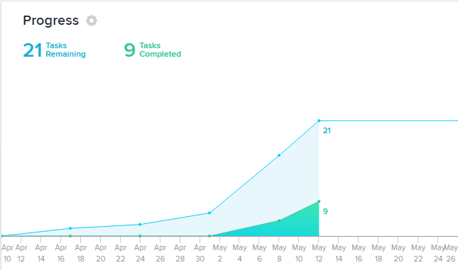

Con’s

* No workflow board
* Progress chart doesn’t show burn down, rather burn up (although that might be acceptable for James)

# Rally

Pros:

* Good workflow board
* Automatic reporting (burn-down)

Cons:

* Not easy to learn
* Burndown doesn’t track hours on the weekend so charts look funny
* Probably has more features than we would use

# Trello

Pros:

* Good workflow board
* Seems like not too much overhead to set up (although I haven’t tried) and learn
* Feature rich

Cons:

* Overhead of effort to learn
* No automatic reporting provided (however the Internet has reporting add-ons)